**CN Surprise Test-3**

**Name:** Sahil Kaundal **UID:** 21BCS8197

**Sem:** 4th **Section/Group:** 807/B

**Subject:** Computer Networks **Subject Code:** 20CST-256

**Q1. Enlighten the services provided by network layer to transport layer in detail.**

**Answer.**

**Services provided to the transport layer**

The services provided to the transport layer are as follows −

* **Logical Addressing** − Network layer adds header to incoming packet which includes logical address to identify sender and receiver.
* **Routing** − It is the mechanism provided by Network Layer for routing the packets to the final destination in the fastest possible and efficient way.
* **Flow control** − This layer routes the packet to another way, If too many packets are present at the same time preventing bottlenecks and congestion.
* **Breaks Large Packets** − Breaks larger packets into small packets.
* **Connection Oriented service** − It is a network communication mode, where a communication session is established before any useful data can be transferred and where a stream of data is delivered in the same order as it was sent.
* **Connectionless Service** − It is a data transmission method used in packet switching networks by which each data unit is individually addressed and routed based on information carried in each unit, rather than in the setup information of a prearranged, fixed data channel as in connection-oriented communication.
* **Data Gram** − A datagram is a basic transfer unit associated with a packet-switched network. The delivery, arrival time and order of arrival need not be guaranteed by the network.
* **A virtual circuit** − It is a means of transporting data over a packet switched computer network in such a way that it appears as though there is a dedicated physical layer link between the source and destination end system of this data.

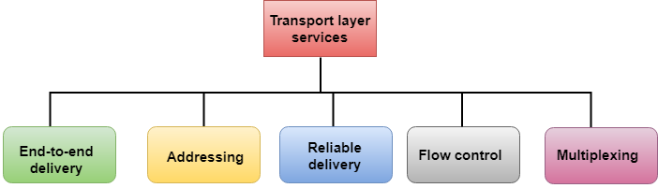

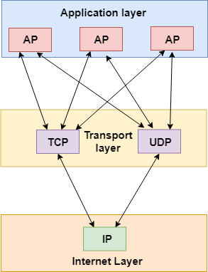

**Q2. Enlighten the network issues in computer networks and also suggest few remedies.**

**Answer.**

**1. Duplicate IP Addresses**

When two devices attempt to share a single IP, you see the dreaded “Address Already in Use” Kill — with no ability to access the network.

**The Quick Fix:** The blame for this often rests with your router’s default DHCP configuration. DHCP is probably trying to assign your new device an address at the beginning of your subnet, and another device may already occupy these low-numbered addresses with static IPs. If you’ve just introduced a new device or server to your network, it may have its own DHCP server. Simply disable the DHCP server on that device to restore sanity to your network.

**2. IP Address Exhaustion**

To troubleshoot this issue, use the ipconfig command. If the workstation has assigned itself an IP address that begins with 169.x.x.x, it means that no IP address was available from the DHCP server.

**The Quick Fix:** Some users on cable internet might not have a local router, in which case IP addresses are assigned on a limited basis directly from your ISP. You have probably run out of allowed IP addresses from your ISP. The solution to this is to purchase either a standalone router or WiFi access point with an integrated router. This creates your own local pool of internal addresses, ensuring you won’t run out.

If you already have a local router with DHCP, the default address pool might be too small for your network. By accessing the DHCP settings on the router, you can adjust the size of the address pool to meet your network’s needs.

**3. DNS Problems**

Errors such as The Network Path Cannot Be Found, IP Address Could Not Be Found, or DNS Name Does Not Exist, can usually be traced to a DNS configuration issue. The command line utility nslookup can be used to quickly show a workstation’s DNS settings.

**The Quick Fix:** Workstations and other network devices can be configured to use their own DNS servers, ignoring the server assigned by DHCP. Checking the ‘Internet Protocol Version 4 (TCP/IP)’ settings for your adapter will show if an incorrect DNS server is specified, so just select “Obtain DNS server address automatically” instead.

**4. Single Workstation Unable to Connect to the Network**

If only a single workstation is displaying the “No internet” message when opening a web browser, we can usually assume that the rest of the network is healthy and turn our attention to any hardware and software that is particular to this system.

**The Quick Fix:** To resolve this network issue, start by eliminating the obvious communication barriers such as a bad cable, poor WIFI signal, failing network card or incorrect drivers. Ensure that the workstation’s network adapter is configured with the correct IP, subnet, and DNS servers.

If that doesn’t solve the problem, check any firewall software on the device to ensure that necessary ports are open to the external network. Common ports include 80 and 443 for web traffic, plus 25, 587, 465, 110, and 995 for email.

**5. Unable to Connect to Local File or Printer Shares**

Sharing problems are among the most difficult network problems to solve, due to the number of components that need to be configured properly.

Most commonly, sharing problems arise due to conflicts between mixed security environments. Even different versions of the same operating system sometimes use slightly different security models, which can make interconnection of workstations difficult.

**The Quick Fix:** We can cure sharing problems most efficiently by drilling down through the possibilities in this order:

1. Ensure that the required services are running. On Windows systems, the server, TCP/IP NetBIOS Helper, workstation, and computer browser services all need to be running. On Linux machines, Samba is the primary component required to share with Windows systems.
2. Check your firewall(s). It’s very common for a workstation’s firewall to be configured to block file and printer sharing traffic, especially if a new antivirus package is installed that introduces its own firewall. Firewall issues can also exist at the hardware level, so ensure that routers or managed switches are passing share traffic within the subnet. Speaking of subnet….
3. Ensure all workstations are on the same subnet. This problem typically only appears on complex networks; however, even simple networks sometimes have static-IP equipment with an improperly configured subnet. The result is that external traffic will move about just fine, while internal traffic will hit unexpected roadblocks.
4. All Windows network adapters will need File and Printer Sharing for Microsoft Networks, Client for Microsoft Networks, and NetBIOS over TCP/IP enabled.
5. Once the above checks have passed, it’s finally time to check the most likely culprit, permissions. There are multiple layers of access required, each with their own interface within the OS. Check for:

* Systems configured with the wrong workgroup or domain.
* Incorrectly configured Home Group.
* Network type set to Public.
* Incorrect NTFS permissions.

**6. Local Network is Unable to Connect to the internet**

This situation can either be intermittent or persistent. Often times, the most difficult aspect of dealing with any external network problem is finding the company responsible. And then tasking them to solve the issue, particularly with intermittent failures that are difficult to trace. It can sometimes be such a problem that organizations will have to switch internet providers in order to solve the issue.

**The Quick Fix:** A router and modem reboot is the first order of business. The tracert then utility can be used to identify communication breaks. It will clearly hiccup on the particular router hop that is causing the problem. Contact your ISP with your findings, providing screenshots as necessary.

**7. Slow Internet Performance**

Slow performance is typically due to congestion, or sometimes poor-quality connections that have corroded or otherwise deteriorated. Congestion may not be directly related to bandwidth exhaustion, as a single overloaded port on a switch or router can diminish network performance.

This can be especially true on leased lines where dedicated bandwidth is to be expected, but speed tests indicate the network is not reaching it’s rated potential.

**The Quick Fix:** Use speed test websites, conducting tests from geographically remote servers. This can pinpoint areas of congestion on the ISP’s network. In the case of cable internet, the local network is shared amongst your neighbours, committing your ISP to a costly bandwidth upgrade when saturation occurs. Report your findings to your ISP so that they can take steps to resolve the issue.